I created a Simple SOC lab in Microsoft Azure in order to practice security configurations and data reading. In support of the SOC lab, I created a honey pot and log analytics workbook to provide data for use in the SOC lab.

Here are snippets of monitoring the failed login attempts on the honey pot, a windows 10 machine.

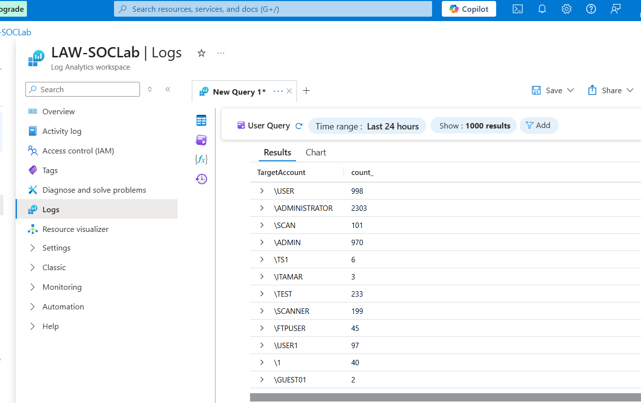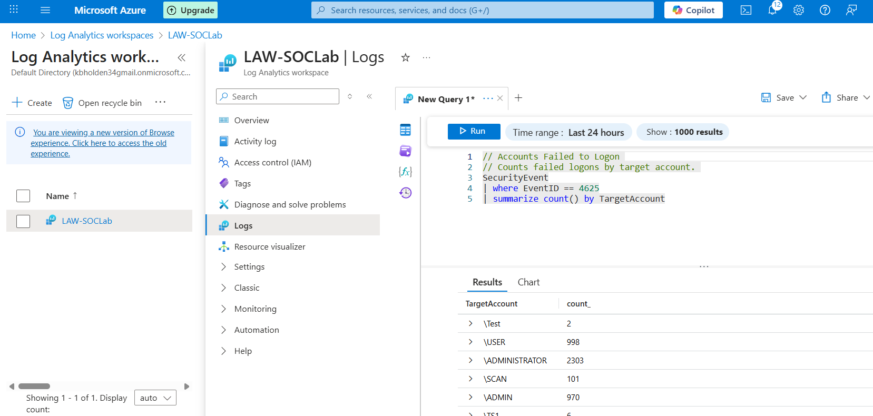

I also created a world map to track locations of the failed login attempts. I used a list of 55,000 Geolocation IP addresses to plot it.

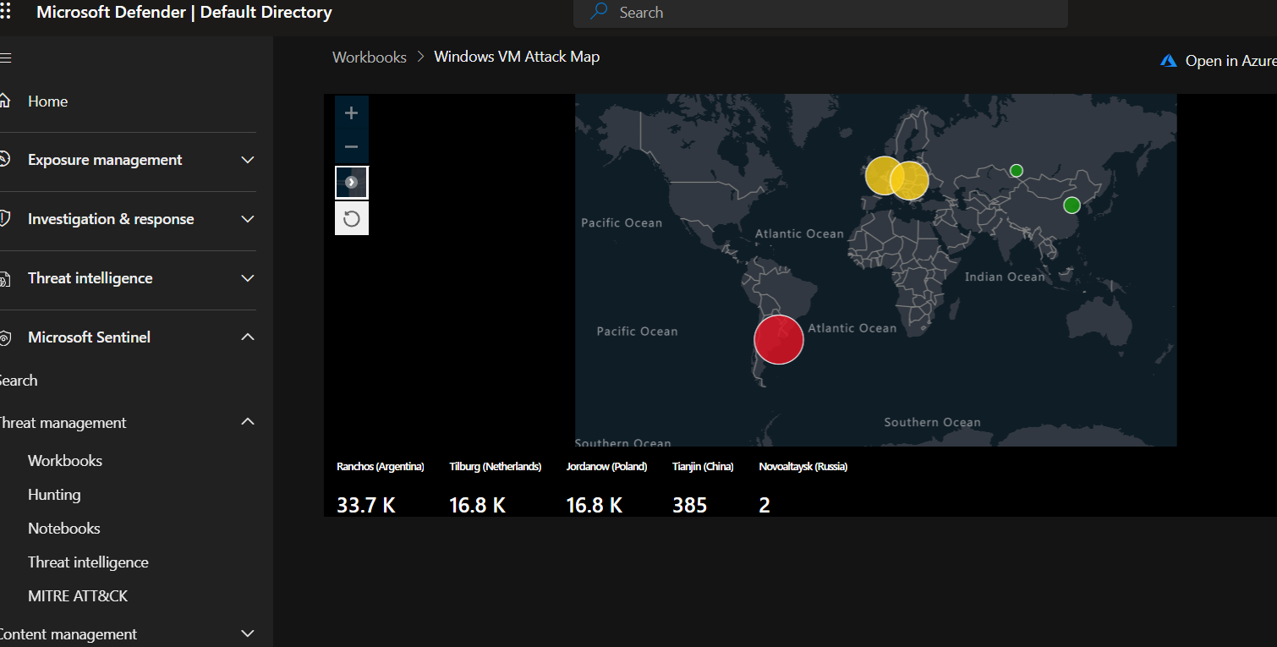

Additionally, here are outtakes of the secure score and overviewing data based on the MITRE ATT&CK framework.